|  | C1 10psi C2 0psi | C1 0psi C2 10psi |
| --- | --- | --- |
| X-displacement (mm) | -4.142 | 4.126 |
| Y-displacement (mm) | -4.162 | -4.135 |

C1 C2

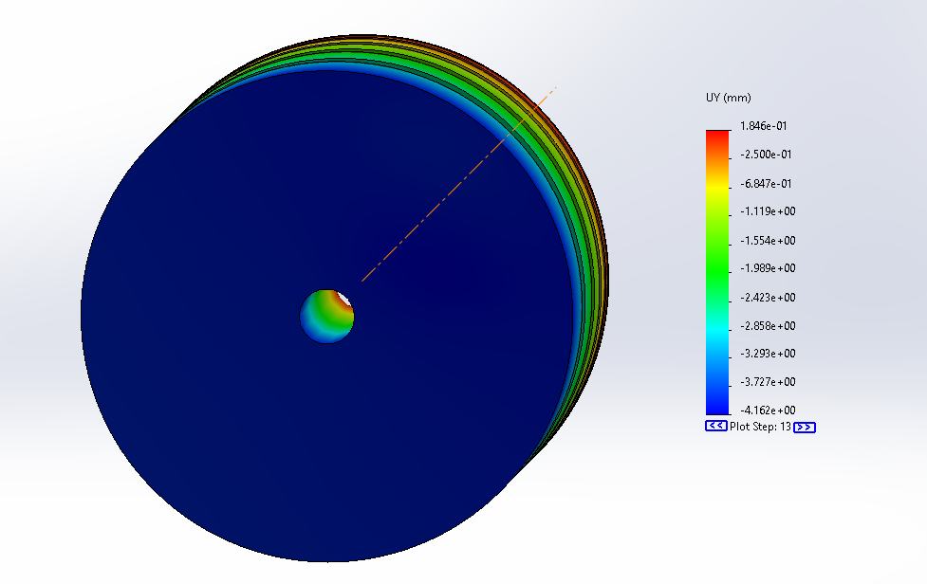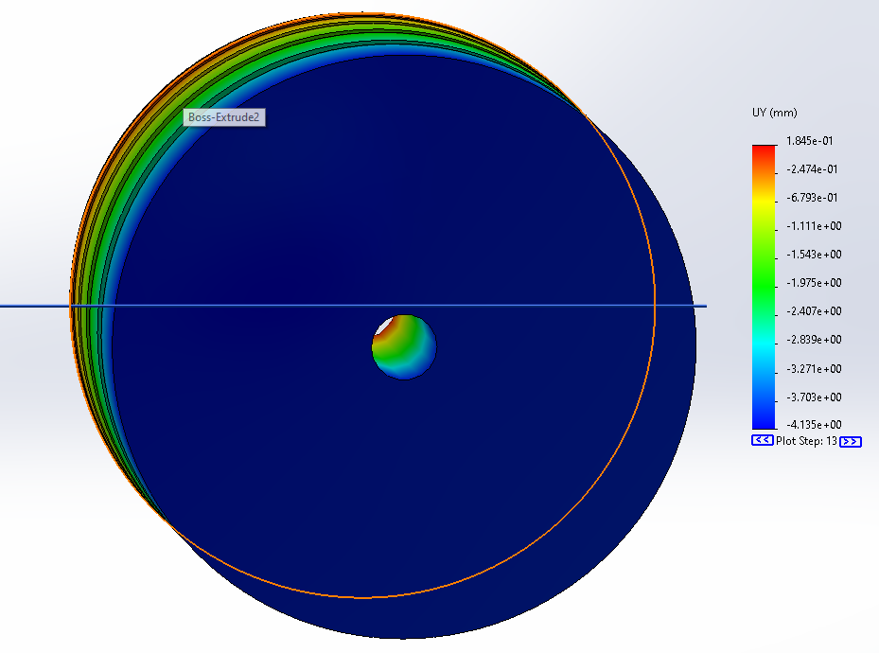

| (x,y) disp. (mm) | C1 0psi | C1 10psi | C1 15psi | C1 20psi | C1 25psi | C1 30psi |
| --- | --- | --- | --- | --- | --- | --- |
| C2 0psi | (0,0) | (-4.142, -4.162) |  |  |  |  |
| C2 10psi | (4.126,-4.135) | (0,-8.244) |  |  |  |  |
| C2 15psi | (6.285,-6.303) | (2.205,-10.44) | (0,-12.69) |  |  |  |
| C2 20psi | (8.515,-8.451) | (4.409,-12.71) | (2.292,-14.99) | (0,-17.34) |  |  |
| C2 25psi | (10.81,-10.85) | (6.86,-15.07) |  |  |  |  |
| C2 30psi | (13.19,-13.24) | (9.036,-17.51) |  |  |  |  |

C1-10 C2-25 failed at 82.7%

C1-10 C2-30 failed at 70.5%

C1-0 C2-30 failed at 90.7%

C1-0 C2-20

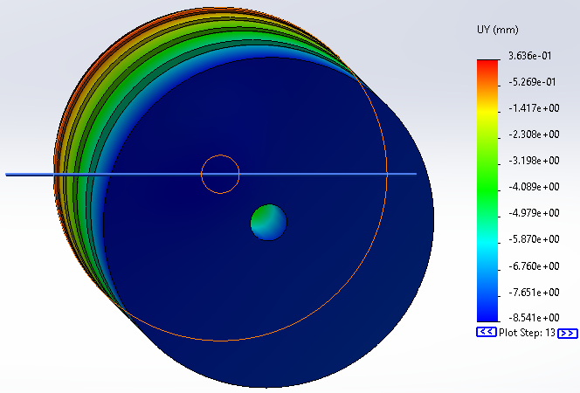

C1-0 C2-25

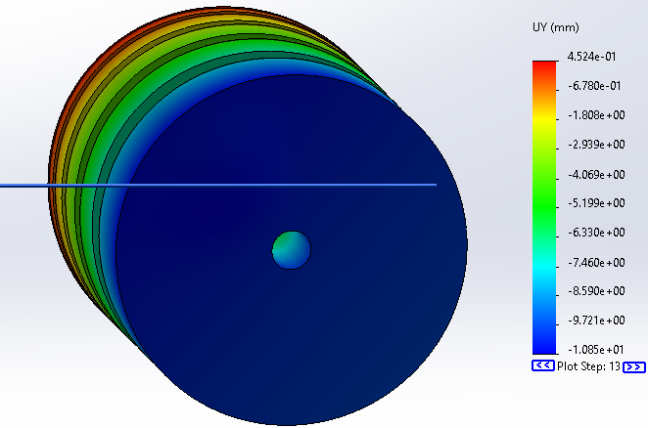

C1-0 C2-30

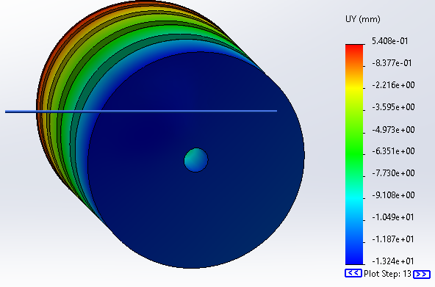

C12-10

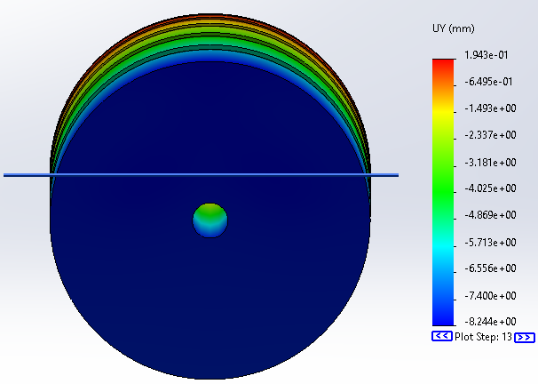

C1-10 C2-15

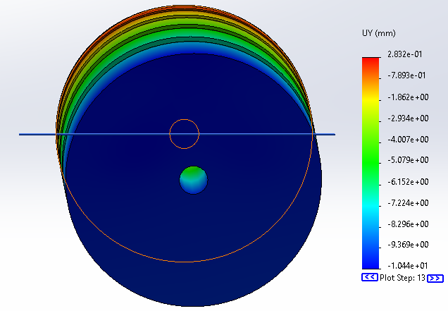

C1-10 C2-20

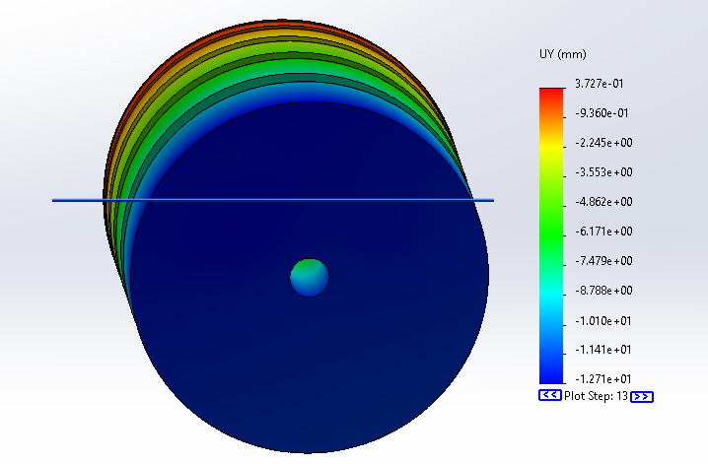

C1-15 C2-15

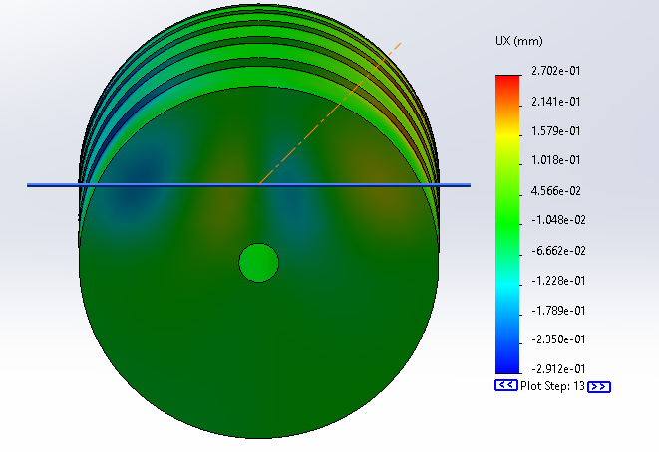

C1-15-20

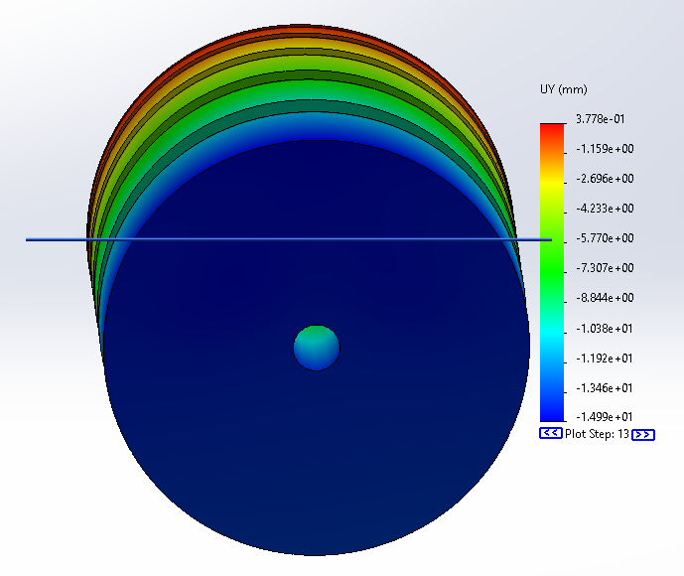

C12-20

